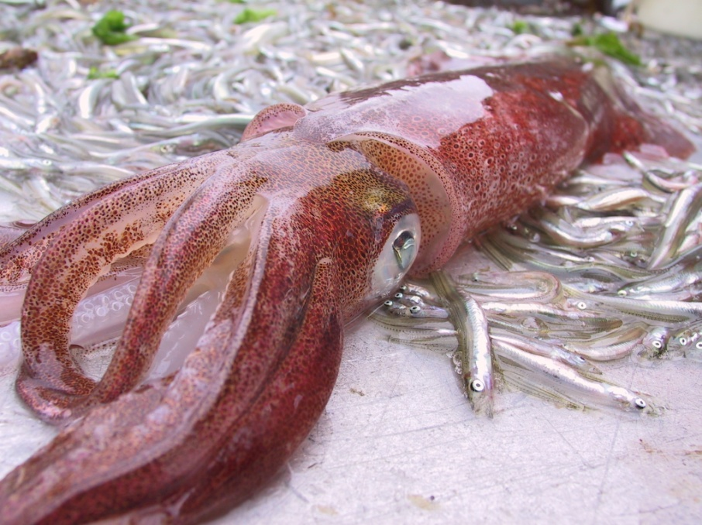
Many people are unaware that long-finned squid (Loligo pealei) are very common in Long Island Sound. In fact they are one of the most common invertebrate species, by weight, caught in the Long Island Sound Trawl Survey (for a slideshow of the Long Island Sound Trawl Survey (LISTS) see: www.ct.gov/dep/lib/dep/fishing/fisheries_management/trawl_show.pdf ). Squid have been one of the top three species caught in the Survey for sixteen out of the last eighteen years. They also comprise a major component to the Sounds forage base for popular sport fish caught by anglers such as striped bass and bluefish. Long-finned squid typically migrate into the Sound in May to feed and spawn and then move back out to the warmer continental shelf waters in the late fall. Squid are in the mollusca phylum and are actually related to clams, oysters and other bivalves; however, squid have an internal shell called a pen rather than the external protective shell of these other molluscans.

Squid have a unique life history and have unique morphological characteristics that set them apart from other invertebrates. Squid grow extremely fast and only live about nine months to a year. Most squid in the Sound are less than a foot long (mantel length) but some have been recorded up to 16”. The larger mature squid show up first in our waters followed by smaller immature individuals. Although squid are known to spawn year round, the majority of squid in the Sound spawn in May through August. The Long Island Sound Trawl Survey (LISTS) will catch clusters of egg capsules, or “egg mops”, which are often laid on some sort of object like fucus (a common alga in the Sound) or other solid object on the bottom. Squid are social spawners, so each one of these egg mops may be comprised of hundreds of egg capsules from several female squid. Egg mops caught in LISTS are typically less than 1 foot in diameter; however, other parts of the northeast have recorded clusters as large as two to three feet in diameter. Within two to three weeks, depending on water temperature, the eggs will hatch and by mid to late September LISTS Fall Survey will often see young squid from 3 to 9 centimeters in mantel length (or 1 to 3 inches long). LISTS largest catch during a fall survey was over 5,800 squid in a single 30 minute tow. In some years where squid are particularly abundant the survey has actually averaged upwards to 270 squid per tow.
One of the most fascinating things about long-finned squid is their ability to change color and the patterns of their skin. Like other cephalopods, including octopus, they are often described as the “masters of camouflage”. They have the ability of using their well studied nervous system to control the underlying skin cells to change their color. Squid can selectively control reflecting cells called leucophores and chromatophores which are organs that contain different types of pigment that result in a wide array of varying iridescence. Looking closely at the surface of the skin one can see many small dots which are the chromatophores. Different colored chromatophores are controlled by muscles which relax or contract to form the overall shape and color pattern.
Although long-finned squid inhabit Long Island Sound, there hasn’t been much of a directed fishery on them in several years. Recent historical landings for Connecticut recorded as much as 412,547 in 1995 but are now down to 11,000 to 33,000 pounds in the last few seasons. Long Island Sound is relatively only a small portion of the squids geographical range, which extends from Newfoundland to the Gulf of Venezuela, but it is a very important nursery area where the species can flourish.

The article was written by Kurt Gottschall of CT DEP’s Marine Fisheries Division.

